IMAS SQL
Tutorial 1b

Adapt the code below to create the Doctor and Clinic tables.

CREATE TABLE Nurse
(NurseNo varchar(4) NOT NULL,
Name varchar(30) NOT NULL,
CONSTRAINT Nurse_NurseNo_pk PRIMARY KEY (NurseNo));

Remember to use the Attribute names given below and use the keywords VARCHAR for text and NUMBER for number.

Doctor:
DoctorNo text(5) Primary Key
Name text(30)
Specialism text(20)

Clinic:
ClinicNo text(4) PrimaryKey
ClinicDescription text(30)
MaxNoOfPatients number

Now try using the code that would not work for the ClinicSession table.

CREATE TABLE ClinicSession
(ClinicNo varchar(4) NOT NULL,
ClinicDate date NOT NULL,
RoomNo varchar(4) NOT NULL,
DoctorNo varchar(5),
NurseNo varchar(4) NOT NULL,
CONSTRAINT clinic_session_pk PRIMARY KEY (ClinicNo,ClinicDate),
CONSTRAINT Clinicsess_Clinic_fk FOREIGN KEY (ClinicNo) REFERENCES Clinic(ClinicNo),
CONSTRAINT Clinicsess_Doctor_fk FOREIGN KEY (DoctorNo) REFERENCES Doctor(DoctorNo),
CONSTRAINT Clinicsess_Nurse_fk FOREIGN KEY (NurseNo) REFERENCES Nurse(NurseNo));

It will now work as we created all the owner tables (Nurse, Doctor, Clinic) before creating the member table (ClinicSession) for all our relationships.

Once all your tables have been created, add the following data (populate your tables). You can add the records by cutting and pasting: You must add data to tables in a particular way.

If data in a member table is referencing data in an owner table, the owner table MUST contain the referenced data. Therefore we must add record(s) to the owner table first.

Cutting and Pasting the tables below into your database tables:

Using the data in the Nurse table given below, highlight the rows of data (not the headings)

Nurse Table:

NurseNo | Name
N024 | Margery Simson
N028 | Patrick Star
N035 | Peggy Hill
N056 | Angelica Pickles

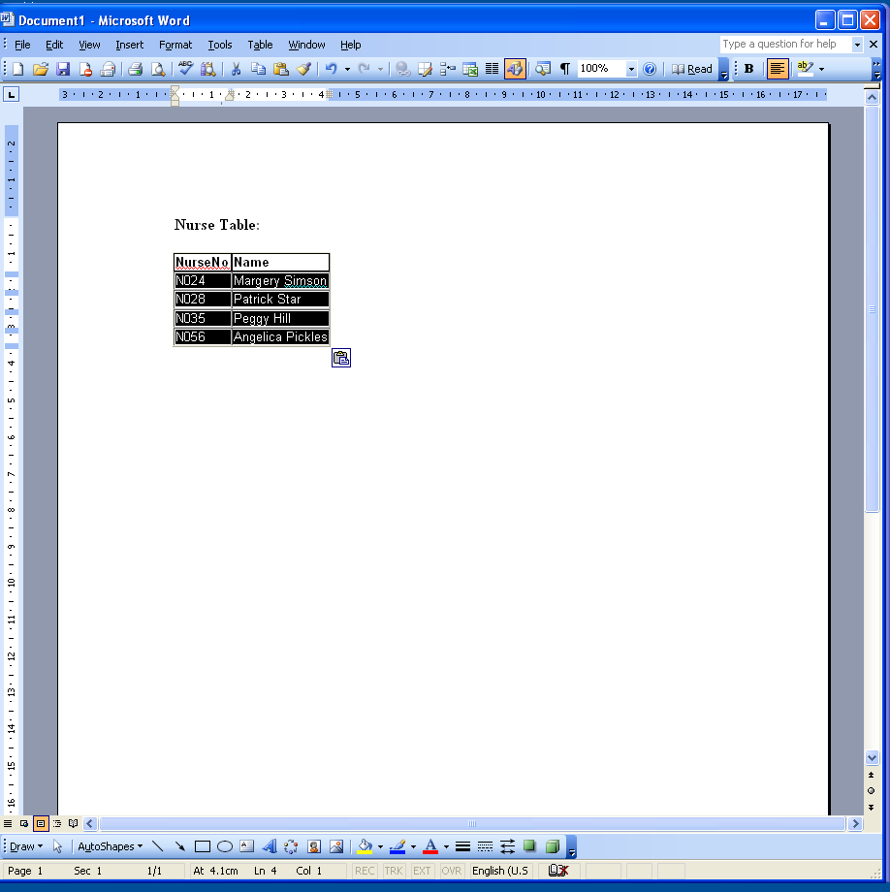

Copy this data using Ctrl C (Pressing the Ctrl button, holding it down then pressing C)
Open the Nurse table in your Access database (Surgery)


Sometimes Access will present this message to you
Simply click on Options

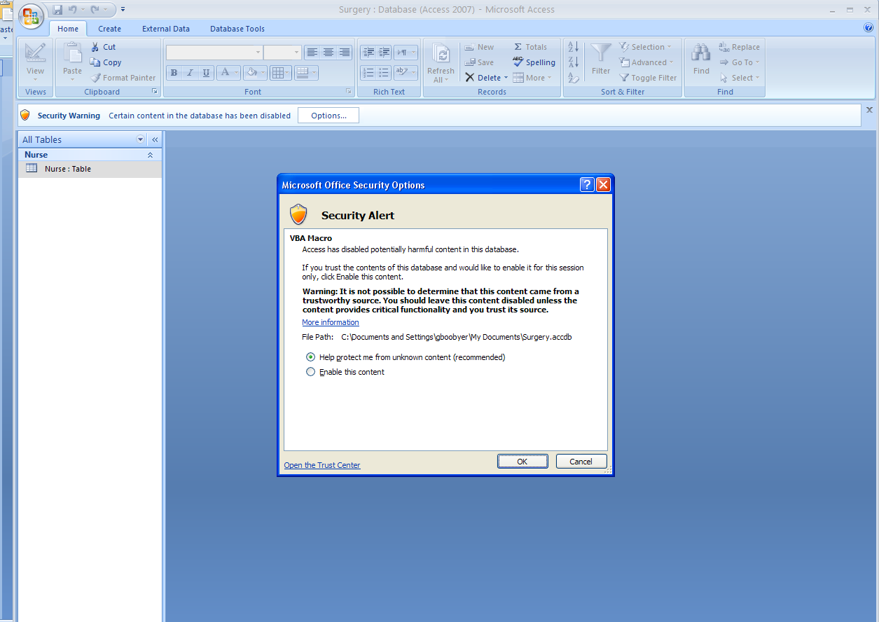
Click on the Radio Button to change to :
Enable this Content

Then click on OK

Double Click on the Nurse:Table


Click on the * to highlight the WHOLE ‘row’ in this table


Paste this data using Ctrl V (Pressing the Ctrl button, holding it down then pressing V)
Your database Nurse table should look like this:

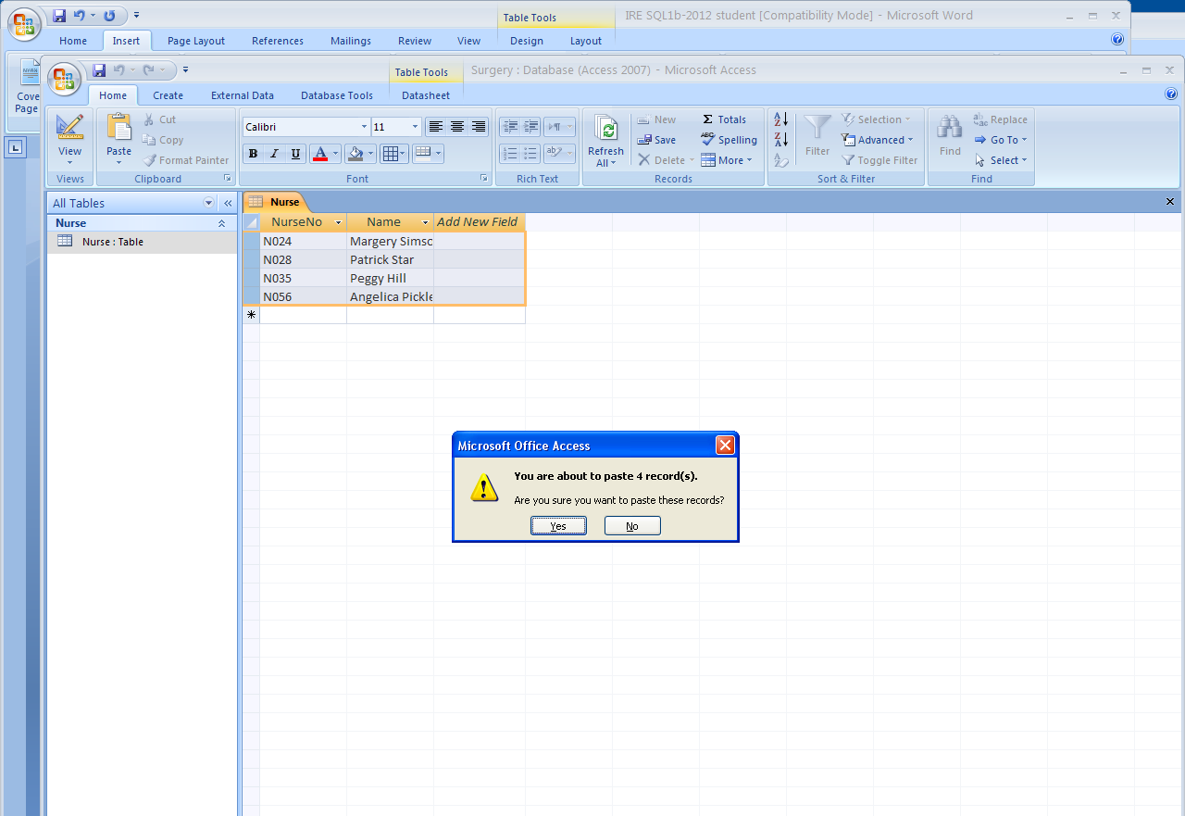

Click ‘yes’ to paste the records into the Nurse table.

Repeat the process for the rest of the tables.

Doctor Table:

DoctorNo | Name | Specialism
D006 | Claudius Cesare | Speech Therapy
D024 | Rhett Butler | Cardiac Problems
D055 | Walter Beatty | Gynecology
D002 | Bradley Pitt | Cardiac Problems
D027 | Charles Prince | Ear,Nose and Throat
D033 | Russell Brando | Gynecology
D014 | Eva Gardner | Cardiac Problems
D019 | Peter Griffin | Gastric Problems
D028 | Barbarella Striesand | Ear,Nose and Throat
D022 | Lois Griffin | Pediatrics
D036 | Margaret Simpson | Pediatrics

Clinic Table:

ClinicNo | ClinicDescription | MaxNoOfPatients
C027 | Well Woman Clinic | 15
C028 | Audiology Clinic | 5
C035 | Cardiac Clinic | 10
C040 | Speech Therapy | 5
C045 | Well Man Clinic | 15
C067 | Baby Clinic | 15
C023 | General Nursing Clinic | 10

Clinic Session Table:

ClinicNo | ClinicDate | RoomNo | DoctorNo | NurseNo
C067 | 08/10/14 | R001 | D022 | N024
C040 | 09/10/14 | R102 | D006 | N028
C028 | 10/10/14 | R210 | D028 | N035
C045 | 10/10/14 | R001 | D019 | N024
C027 | 11/10/14 | R210 | D055 | N035
C035 | 11/10/14 | R210 | D024 | N056
C067 | 13/10/14 | R001 | D036 | N056
C040 | 13/10/14 | R210 | D006 | N028
C027 | 18/10/14 | R210 | D033 | N024
C045 | 17/10/14 | R001 | D024 | N056
C028 | 17/10/14 | R210 | D027 | N024
C035 | 19/10/14 | R210 | D014 | N056
C067 | 22/10/14 | R001 | D022 | N024
C040 | 22/10/14 | R102 | D006 | N028
C028 | 24/10/14 | R210 | D028 | N035
C045 | 24/10/14 | R001 | D019 | N024
C027 | 25/10/14 | R210 | D055 | N035
C035 | 01/11/14 | R210 | D024 | N056
C067 | 03/11/14 | R001 | D036 | N056
C040 | 03/11/14 | R210 | D006 | N028
C027 | 01/11/14 | R210 | D033 | N024
C045 | 31/10/14 | R001 | D024 | N056
C028 | 31/10/14 | R210 | D027 | N024
C035 | 02/11/14 | R210 | D014 | N056

Once you have successfully added the above data, try adding the following record:

ClinicNo | ClinicDate | RoomNo | DoctorNo | NurseNo
C066 | 10/11/14 | R001 | D036 | N056

You will not be allowed to add this data and Access will continually prompt you for valid data. You must close the table using the 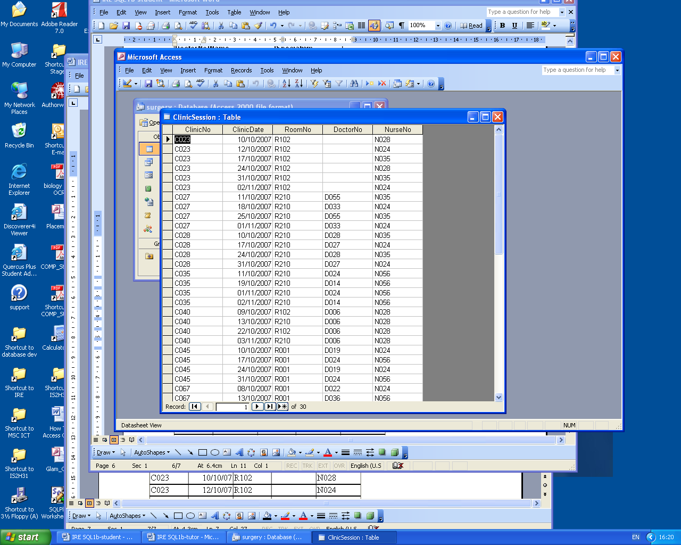 icon in order to come out of the table.

Why are you not allowed to add this record?

Try adding the following record:

ClinicNo | ClinicDate | RoomNo | DoctorNo | NurseNo
C067 | 11/11/14 | R001 | D038 | N056

Why are you not allowed to add this record?

Try adding the following record:

ClinicNo | ClinicDate | RoomNo | DoctorNo | NurseNo
C067 | 12/11/14 | R001 | D036 | N055

Why are you not allowed to add this record?

Try adding these records:

ClinicNo | ClinicDate | RoomNo | DoctorNo | NurseNo
C023 | 10/10/14 | R102 |  | N028
C023 | 12/10/14 | R102 |  | N024
C023 | 17/10/14 | R102 |  | N035
C023 | 24/10/14 | R102 |  | N028
C023 | 02/11/14 | R102 |  | N024
C023 | 31/10/14 | R102 |  | N035

Why did this work? Hint: look at the create table Clinic Session statement in tutorial 1a.

